Name | Kaushik Balaji. M. S
Roll no | 152502010
Date | 18-Oct-2025

GitHub repo - SoCD Programming lab

CS5107 Programming Lab
Assignment 2

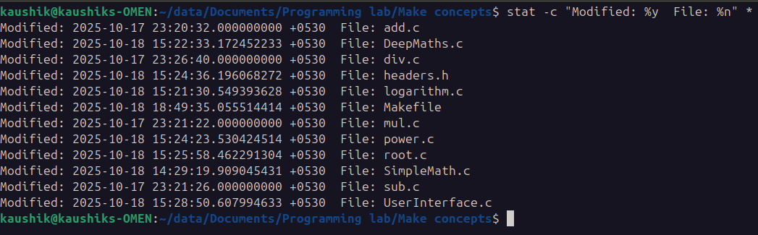Figure 1: Initial file modified times
This image gives the modified time of each files.

After making small modification to the print statement inside SimpleMath.c file, the modified time become as,

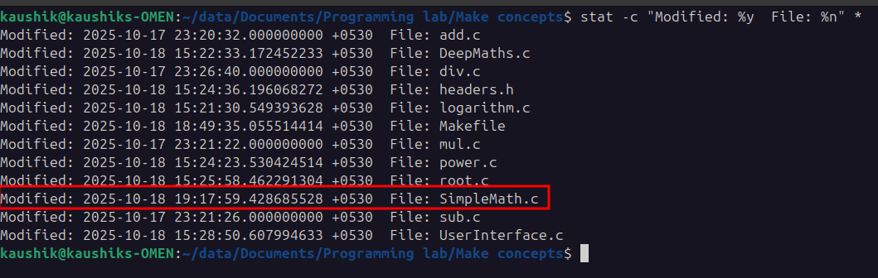Figure 2: File modified time after changing 1 file

Doing “make” adds new .o files for the corresponding .c files.
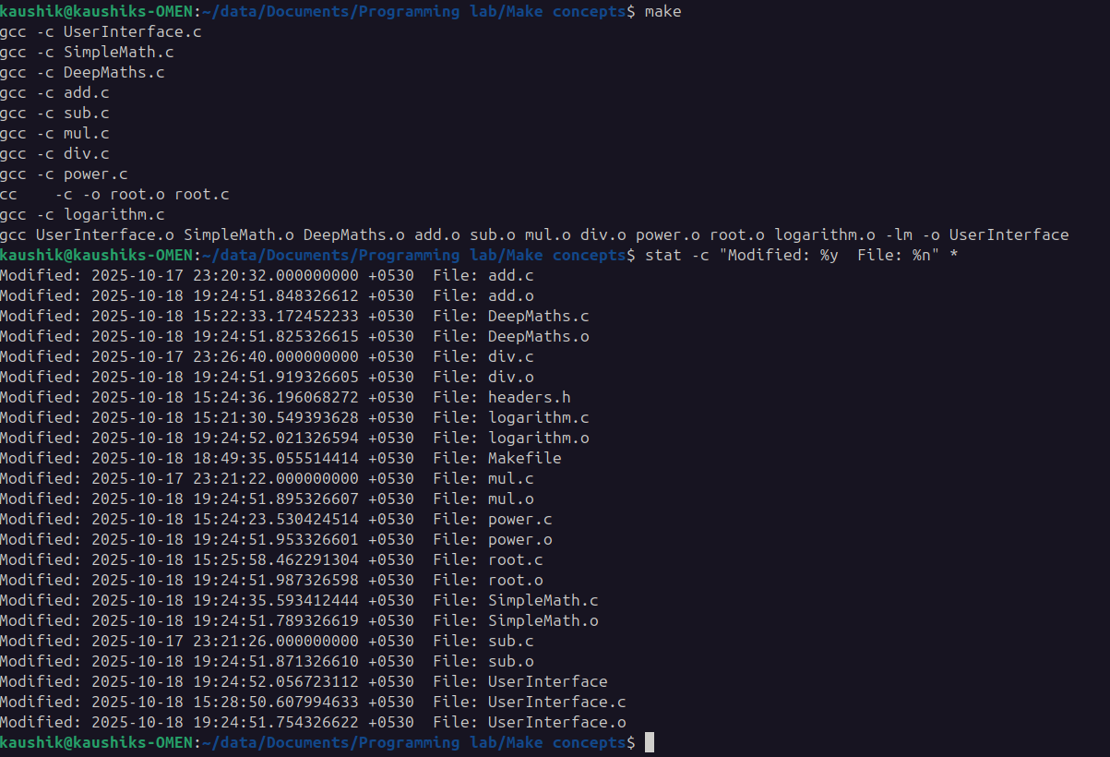Figure 3: New files added after make and their modified times shown
Code runs good.
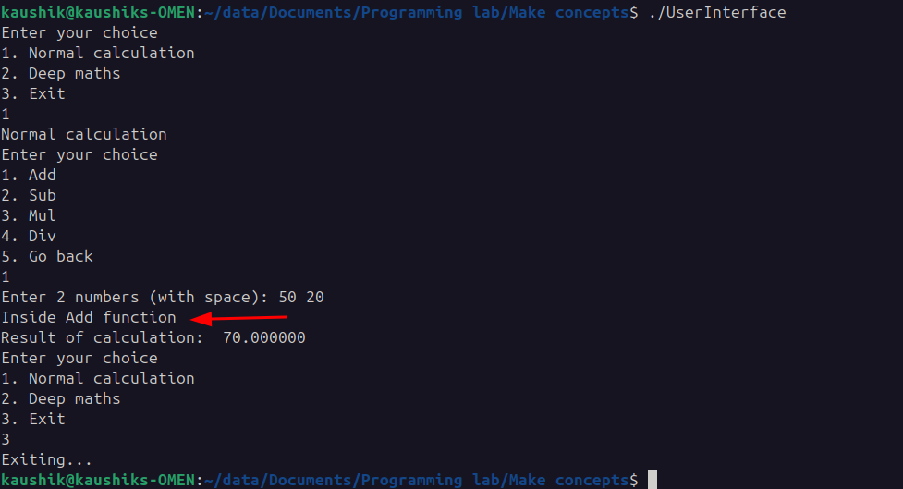Figure 4: Code Execution with the added debug line

After a small print line to the logarithm.c and running “make” again, the Makefile does the compilation just for the newly changed file.

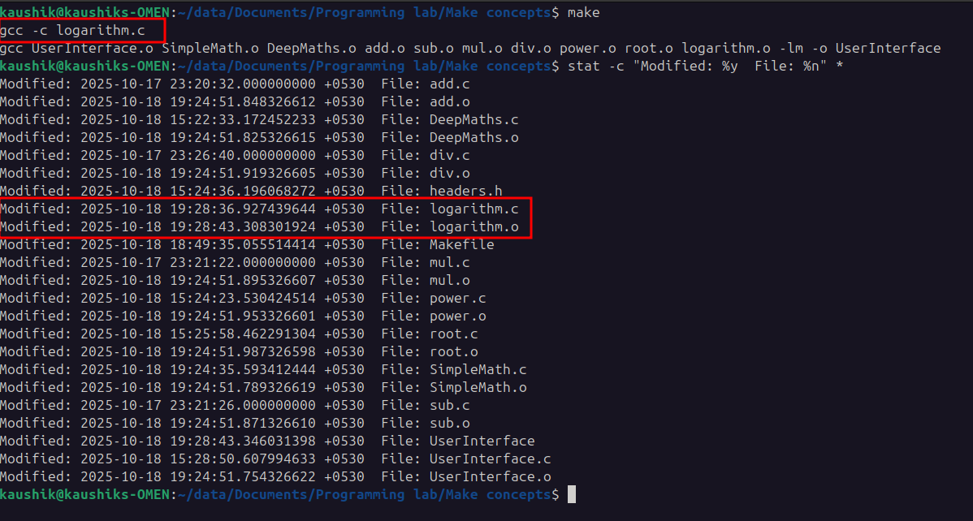Figure 5: Modified timestamps after modifying 1 file and doing make
As it can be seen from the above image, “make” compiled only the modified logarithm.c file and gave logarithm.o and it made a new executable, as it was dependent on logarithm.o.
Other file’s timestamp remains the same (can be compared with Figure 3 and Figure 5).

